Spalding – Strategic case for change
Spalding Town boundary based on Built Up Area 2022 definition
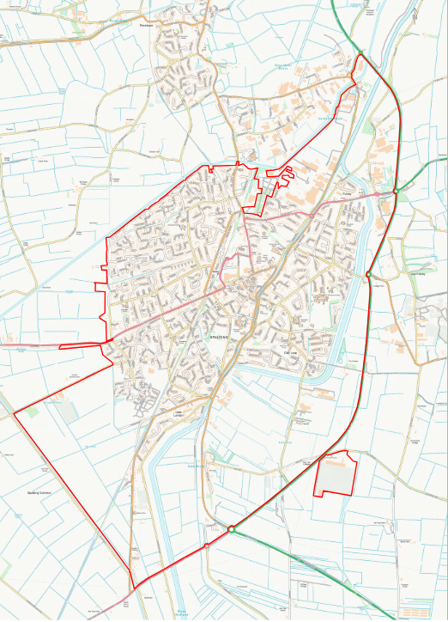
Figure 1 - Map of Spalding Town Boundary
The boundary for Spalding town is based on ONS Built Up Area 2022 data. This reflects the approach set out in the Long-Term Plan for Towns guidance for defining the geographical area covered by the Town Board.
The map shown in Figure 1 also includes data from the Consumer Data Research Centre (CDRC) showing Retail Centre Boundaries, to provide additional information linked to the High Streets, Heritage and Regeneration policy investment theme.

DLUHC Data Pack Summary
Relative strengths in employment rate, broadband access, outlets per person and low commercial vacancies; relative weaknesses in social trust, low footfall and low skills
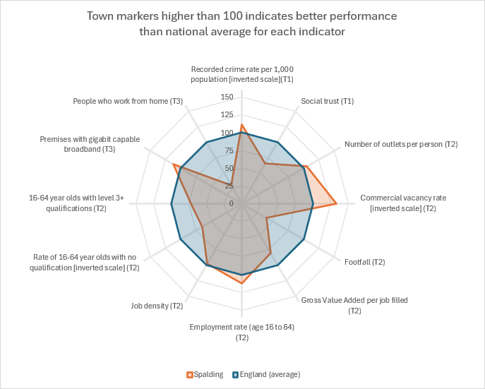
Figure 2 - Summary of DLUHC data pack analysis
Department for Levelling Up, Housing and Communities (DLUHC), in collaboration with Office for National Statistics (ONS), produced a high-level data pack to support the development of the Spalding vision for the Long-Term Plan for Towns programme, with a range of data based on the three policy investment themes:
- T1 – Safety and Security
- T2 – High Streets, Heritage and Regeneration
- T3 – Transport and Connectivity
In Figure 2 above, the key statistics for Spalding in this data pack have been compared to national averages. A town marker higher than 100 indicates better performance than the national average. Where necessary, the scale has been inverted to ensure that a higher score indicates better performance – for example, lower-than-average crime rates (T1) in a town will have a score higher than 100.
1. Safety and security
Low crime rates but also low levels of social trust
As shown in Table 1, Spalding has a lower-than-average crime rate (although not as low as the South Holland District Council area as a whole). It also has low levels of social trust as reported by the think-tank Onward in its January 2023 Good Neighbours report.
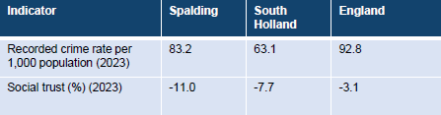
Table 1 – Crime rates and social trust levels in Spalding
This information should be considered alongside data on levels of deprivation in Spalding. Analysis of Onward data suggests that social trust is strongly correlated with deprivation. Spalding’s levels of social trust are particularly low given the relative affluence of neighbourhoods (Middle Super Output Areas) in Spalding, as shown in Figure 3.
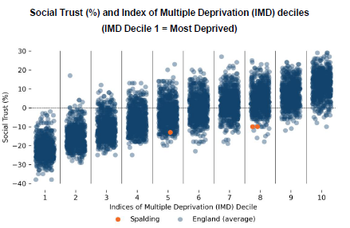
Figure 3 – Social Trust at MSOA level compared to IMD decile
The Long-Term Plan vision for Spalding has an opportunity to link with existing community safety strategies in the area. South & East Lincolnshire Community Safety Strategy for 2022-2025 is based on the following five priorities:
- Tackling Anti-Social Behaviour
- Hate Crime
- Safer Streets & Night-Time Economy
- Vulnerability & Safeguarding
- The Safety of Women & Girls.

2. High Streets, Heritage and Regeneration
Relative strengths in number of outlets and low commercial vacancies, but low footfall levels in the town
The DLUHC data pack suggests that Spalding has some relative strengths in terms of its leisure and entertainment outlets and low commercial vacancy rates. Footfall within the town is, however, markedly lower than the national average.
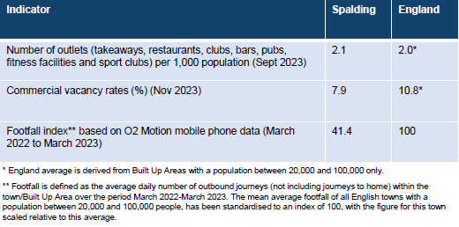
Table 2 – Leisure and retail statistics for Spalding compared to national average
In 2023, Spalding Town Forum launched the Love Spalding brand to reflect and promote pride in place alongside consultation on pedestrianisation of Spalding town centre. Following the announcement of the Long-Term Plans for Towns funding, Love Spalding is now the adopted name for the development of the funding in Spalding.
DLUHC data suggests that Spalding has low skills and productivity but more positively the employment rate is high
DLUHC data indicates that there are low skills and productivity in Spalding (although more positively the employment rate is higher than the regional and national average) – The term GVA stands for “Gross Value Added” a statistical measure of the economic value of the outcomes from the work people do. Level 3 qualifications are the benchmark for people moving on towards higher level skills.
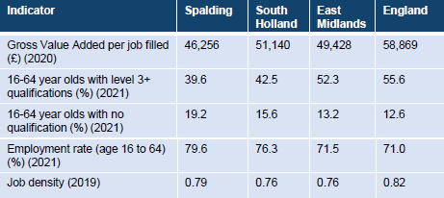
Table 3 – Skills and employment indicators for Spalding compared to national average
£20m Levelling Up funding for the Castle Sports Complex will make an important contribution to regeneration in Spalding
In 2023, it was announced that South Holland District Council will receive £20m of Levelling Up funding for the Castle Sports Complex in Spalding (with a further £6m from SHDC). The November 2023 announcement from South Holland District Council explained:
‘After submitting a bid in August [2023], the Government has this week confirmed the success of the application, which will look to create a new and improved offer focused around health, wellbeing, leisure, sport, recreation and community spaces.
‘The ambitious plans the Council submitted included proposals for a new 3G floodlit football pitch to allow play all year round, a changing pavilion, a multi-use games area for a variety of other sports and three new swimming pool facilities including a large pool, a teaching pool and a splash pad.
‘The bid also sought funding to provide community rooms and space dedicated for use to provide a health and wellbeing hub including services for mental health, diabetes, Alzheimer's and dementia support, as well as an Extra Care housing scheme for the District's older residents.’

3. Transport and Connectivity
Good online connectivity to enable digital working, but low levels of people working from home
The DLUHC data pack includes information on two indicators related to connectivity enabling digital working as shown in Table 4 below. First, Spalding has an above average proportion of premises with gigabit capable broadband (and markedly higher figures than South Holland district). Secondly, however, Spalding has a low proportion of people working from home. Digital connectivity can be an important facilitator for home-working in knowledge-intensive industries and, as such, the proportion of people working from home is a proxy for good household digital connectivity.
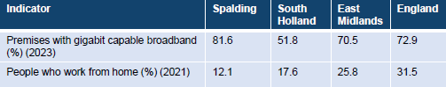
Table 4 – Digital connectivity indicators for Spalding compared to national average
Reasonable access to key local services (apart from hospital access)
Average journey times for Spalding residents to key services are broadly in line with national averages for all types of services with the exception of journey times to a hospital.
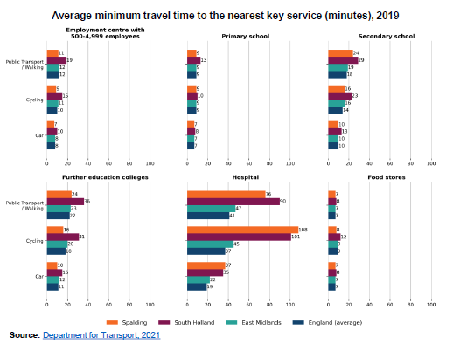
Figure 4 – Average journey times to key services by mode of transport
Levelling Up funding for the A16 corridor between Boston and Spalding will improve connectivity, especially for the agri-food industry
In October 2021, Lincolnshire County Council received £20m in Levelling Up funding to support a range of road infrastructure projects on the A16 corridor between Boston and Spalding, which is a key route for the agri-food industry. The funding aims to:
- Reduce congestion along the A16 corridor between Boston and Spalding
- Address the major connectivity issues impacting the A16
- Provide improved walking and cycling facilities along the corridor
- Open up the area for further investment opportunities
- Complement other local transport and renewal projects underway or planned in Lincolnshire

4. Deprivation and demographics
Overall, Spalding does not have high levels of deprivation, but it is deprived in terms of Education, Skills and Training
Analysis of the England Indices of Deprivation 2019 (IMD 2019) demonstrates that Spalding is overall a relatively affluent area, with 0 out of 17 LSOAs in the most deprived 20% nationally and 3 out of 17 LSOAs (17.6%) in the most deprived 40%.
However, the situation is notably different for the Education, Skills and Training domain (one of seven domains that comprise the IMD): 6 out of 17 LSOAs are in the most deprived 20% nationally and 14 out of 17 LSOAs (82.4%) are in the most deprived 40%, as shown in Figure 5 below.
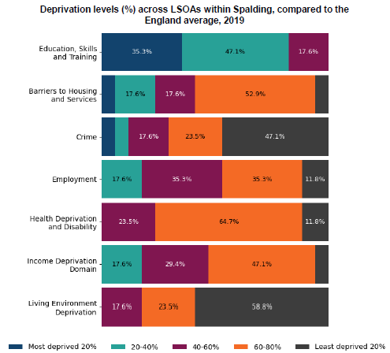
Figure 5 – Analysis of deprivation levels in Spalding by IMD domain

Spalding’s population is growing faster than local, regional and national averages
Spalding’s population in 2021 was 30,552 – an increase of 11.3% since 2011, which is a proportionally greater change than the South Holland district change (7.8%), the East Midlands change (7.6%) and the England population change (6.6%).
Spalding’s age profile is very similar to England overall profile
The average (median) age for Spalding is 40 years compared to an England average of 39 years (based on 2021 Census data). The median age in Spalding did not increase between 2011 and 2021, compared to an England-wide increase of 1 year over the same period.
18.0% of people in Spalding are under 16 years old and 19.4% are aged 65 and over. For context, the England average was 18.6% and 18.4% respectively (see Figure 6 below).
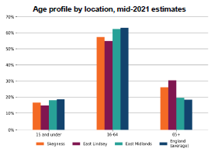
Figure 6 – Analysis of deprivation levels in Spalding by IMD domain
Spalding has a very high proportion of its population with ‘Other White’ ethnicity, reflecting the high levels of migrant workers in the town
In the 2021 Census, for LSOAs wholly or partially within the Spalding Town boundary, 8,003 out of 34,138 people (23.4%) identified their ethnicity as ‘Other White’, compared to an England average of 6.3%. This markedly higher proportion reflects the high levels of migrant workers in the town.
Summary
Spalding is the food hub for Lincolnshire. It is a relatively small settlement compared to its nearest neighbours, Boston, Peterborough and Kings Lynn. Nonetheless the town has a distinctive character and a relatively larger hinterland. It has an interesting Town Centre with opportunities and challenges associated with the proximate retail development Springfields which is based on the edge of the town.
The Long Term Plan for Towns is a good opportunity to build on previous Town Fund and Levelling Up investment. It provides scope for sustainable long term solutions. This funding is different in that it can be invested over 10 years to not only improve the town but provide an ongoing income stream to support longer term development.
The Long Term Plan for Towns provides a menu of activities for which the funding can be used. This is not an exhaustive list and there is scope to suggest other activities within the three themes.
The data set above indicates the scope for further investment in the town in relation to its retail offer and its high level of vacant retail units. The strong presence of people from central and eastern Europe also provides a context to build on the cultural and community cohesion activities which already have a track record of development in the town. There are some significant redundant buildings in the town centre and this funding provides an opportunity to repurpose these facilities.
The relatively low skills and resulting low wages in the town suggest that an additional theme for the development of the Long Term Plan might be around facilitating improvements in this context.

ANNEX – Key Themes in More Detail
The core activities are set out in the list below – they are also in Annex C of the Guidance for the Long Term Plan for Towns:

Transport and connectivity interventions
T1: Support for active travel enhancements in the local area. This might include:
- creation of new foot paths and cycle paths, particularly in areas of health need or social inequalities
- upgrading of existing foot paths and cycle paths, particularly in areas of health need or social inequalities
T2: Funding for bus infrastructure and connections to speed up journeys. This might include:
- traffic signalling improvements
- bus lanes and corridors
- improved passenger information
T3: England and Scotland Only: Additional revenue funding added to the Bus Service Improvement Programme Plus (BSIP+) funding model from June 2024 - that would award funding to LTAs based on a connectivity scoring so they could undertake activities that would boost economic growth.
T4: Funding for new, or improvements to road networks to improve access within and to the town. This might include:
- traffic management improvements to relieve congestion
- road safety
- highway maintenance (including potholes)
T5: Funding to improve rail connectivity and access. This might include:
- adding stations along existing lines
- improved accessibility and journey quality at and around stations
- improved passenger information
T6: Reducing vehicle emissions. This might include:
- EV charging facilities
- procuring zero emission buses
T7: Investment and support for digital infrastructure for local community facilities.

High streets, heritage and regeneration interventions
H1: Funding for place-based regeneration and town centre and high street improvements, which could include better accessibility for disabled people, including capital spend and running costs. This might include:
- regenerating a town square or high street
- public realm improvements, for example street furniture or other decorative improvements
- the delivery of outreach, engagement and participatory programmes for community spaces, including youth centres and public libraries
H2: Funding for new or improvements to existing, community and neighbourhood infrastructure projects and assets including those that increase communities’ resilience to natural hazards, such as flooding, and support for decarbonisation of facilities, energy efficiency audits, and installation of energy efficiency and renewable measures in community buildings (including capital spend and running costs). This might include:
- building new or updating existing defences to increase communities’ resilience to natural hazards like flooding or costal erosion
H3: Creation of and improvement to local green spaces, community gardens, watercourses and embankments. Improvements to the natural environment and the incorporation of more of these natural features into wider public spaces. This might include:
- development of a new park, particularly in areas with the least access to greenspace
- development of a new park or community garden
- improvements to a canal towpath, particularly in more deprived neighbourhoods
- urban or riparian tree planting
- changes to management of green spaces and verges
- regeneration of existing parks or community gardens, particularly in areas with poor quality parks and gardens
- improving access to existing parks
H4: Enhanced support for arts, cultural, heritage and creative activities, projects and facilities and historic institutions that make up the local cultural heritage offer. This might include:
- the delivery of events programmes for community spaces, including youth centres and public libraries
- the development, restoration or refurbishment of local natural, cultural and heritage assets and sites
H5: Support for local arts, cultural, heritage and creative activities. This might include:
- funding for maker spaces
- funding for local art galleries, museums, libraries for exhibitions
- support for displays for artists to showcase work
- locally led music and theatre performances, tours, author events and film screenings
- funding for cultural, heritage and creative events
- support for outreach, engagement, participatory programmes as part of wider local arts, cultural, heritage and creative activities
- support for the establishment and development of cultural, heritage collaborative networks to share knowledge locally
H6: Funding for the development and promotion of wider campaigns which encourage people to visit and explore the local area. This might include:
- campaigns promoting the local area and its culture, heritage, leisure and visitor offer to residents and visitors
- campaigns to encourage visitors from further afield to visit and stay in the region, collaborating with other places where appropriate
H7: Funding for impactful volunteering and social action projects to develop social and human capital in local places. This might include:
- funding for local volunteering groups, such as youth charities and carer’s groups
- support for people to develop volunteering and social action projects locally
H8: Funding for local sports facilities, tournaments, teams and leagues; to bring people together. This might include:
- renovation and maintenance of existing sports facilities
- support for community sports leagues
- regeneration of an unused area to build sports facilities
- creation of new 3G sports pitches and other sports facilities
H9: Investment in capacity building, resilience (which could include climate change resilience) and infrastructure support for local civil society and community groups. This might include:
- funding for community spaces, such as village halls, libraries or community centres for local civil society and community groups to use
- support for people to develop volunteering and social action projects locally
H10: Investment and support for digital infrastructure for local community facilities.
H11: Investment in open markets and improvements to town centre retail and service sector infrastructure, with wrap around support for small businesses. This might include:
- funding to support the establishment and ongoing running of a new open air market
- business support activity for entrepreneurs
H12: Funding for the development and promotion (both trade and consumer) of the visitor economy, such as local attractions, trails, tours and tourism products more generally. This might include:
- development of local visitor trails and tours
- grants for the development, promotion and upkeep of local tourist attractions
- development of other local visitor experiences based around the local offer
H13: Grants to help places bid for and host international business events and conferences that support wider local growth sectors. This might include:
- grants to bid for, secure and hold a conference for a leading sector locally

Safety and security interventions
S1: Design and management of the built and landscaped environment to ‘design out crime’. This might include:
- promoting the active use of streets and public spaces throughout the daytime and evening
- improvements to streetlighting
- installation of new CCTV
S2: Engage with Police Force and together consider interventions to focus on visible crime prevention in defined areas places. Interventions could include:
- hotspot policing
- problem-oriented policing
S3: Measures to prevent anti-social behaviour, crime and reduce reoffending. These might include:
- sports programmes designed to prevent crime and reduce reoffending
- mentoring
- police-led pre-charge diversion models for young offenders
- focused deterrence strategies
- halfway house programmes
S4: Measures to reduce repeat burglary. These might include:
- Neighbourhood Watch
- provision of crime prevention advice
- property marking
- target hardening (increasing the security of a property)
- cocoon watch (provision of crime prevention advice, support and guidance to neighbours and surrounding addresses of burgled properties)
- alley gating

